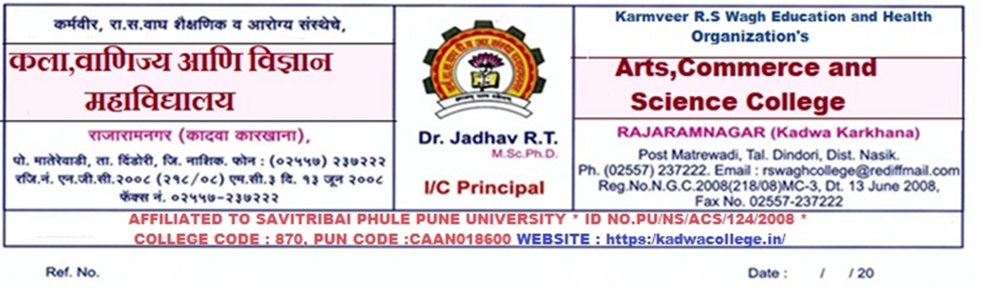

सूचना
सर्व F.Y./S.Y./T.Y.B.A.च्या विद्यार्थ्यांना कळविण्यात येते की ,शैक्षणिक वर्ष २०२३-२४ च्या पहिल्या सत्रातील अंतर्गत मूल्यमापन परीक्षा खालील प्रमाणे आयोजित करण्यात येत आहेत . तरी दिलेल्या वेळापत्रकानुसार सर्वानी परीक्षेसाठी उपस्थित रहावे.
All the students of F.Y./S.Y./T.Y.B.A. are informed that the Internal Evaluation Examination for the first semester of the academic year 2023-24 is being conducted as follows. However, everyone should appear for the exam as per the given schedule.
Sem I Fresher

Date | Time | F.Y.B. A | S.Y.B. A | T.Y.B. A
16/10/2023 | 1st ship  9 am to 10 am | Marathi-G1 | Compulsory English | Compulsory English
16/10/2023 | 2nd ship  11 am to 12 pm | Politics-G1 | Geography-G2 | Politics G-3
17/10/2023 | 1st ship  9 am to 10 am | Compulsory English | ALL Spl.S1 (Eco/poli/Marathi/English | Economics G-3
17/10/2023 | 2nd ship  11 am to 12 pm | Economics-G1 | History G2 / Sociology G2  Optional English G2 | Marathi G-3
18/10/2023 | 1st ship  9 am to 10 am | Geography G | All special -S2 | ALL Spl.S3 (Eco/poli/Marathi/English
18/10/2023 | 2nd ship  11 am to 12 pm | History G/ Sociology G / Optional English G | Marathi G-2 | All special -S4
19/10/2023 | 1st ship  9 am to 10 am |  | Economics G-2 | Basic course all special subject
19/10/2023 | 2nd ship  11 am to 12 pm |  | Politics G-2 | Generic elective
20/10/2023 | 1st ship  9 am to 10 am |  | Basic course all special subject | Geography G3
20/10/2023 | 2nd ship  11 am to 12 pm |  | E.V. S | Optional English G-3 /  History G3 /  SociologyG3

Sem II Backlog

Date | Time | F.Y.B. A | S.Y.B. A | T.Y.B. A
21/10/2023 | 1st ship  9 am to 10 am | Marathi G1 | Compulsory English | Compulsory English
21/10/2023 | 2nd ship  11 am to 12 pm | Politics G1 | Geography G2 | Politics G-3
23/10/2023 | 1st ship  9 am to 10 am | Compulsory English | ALL Spl.S1 (Eco/poli/Marathi/English | Economics G-3
23/10/2023 | 2nd ship  11 am to 12 pm | Economics G | History G2 / Sociology G2 | Marathi G-3
24/10/2023 | 1st ship  9 am to 10 am | Geography G | All special -S2 | ALL Spl.S3 (Eco/poli/Marathi/English
24/10/2023 | 2nd ship  11 am to 12 pm | History G / Sociology G / optional English G | Marathi G-2 | All special -S4
25/10/2023 | 1st ship  9 am to 10 am |  | Economics G-2 | Basic course all special subject
25/10/2023 | 2nd ship  11 am to 12 pm |  | Politics G-2 | Generic elective
26/10/2023 | 1st ship  9 am to 10 am | - | Basic course all special subject | Geography G3
26/10/2023 | 2nd ship  11 am to 12 pm |  | E.V. S | English G-3
26/10/2023 | 1st ship  9 am to 10 am | Marathi | Optional English G2 | History G3 / Sociology G3 / optional English G3

