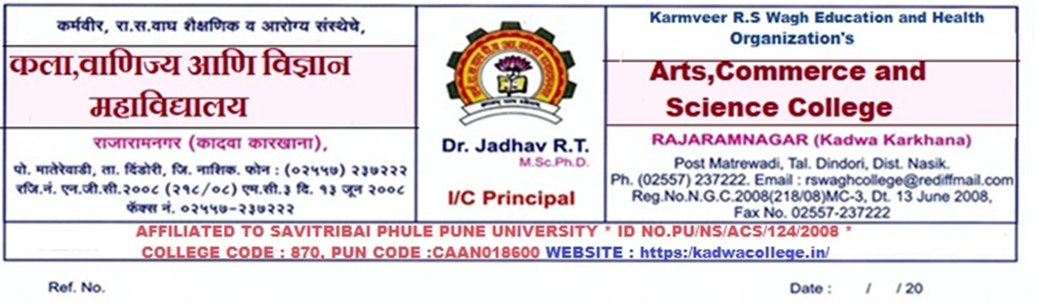

सूचना
सर्व F.Y./S.Y./T.Y.B.Sc च्या विद्यार्थ्यांना कळविण्यात येते की ,शैक्षणिक वर्ष २०२३-२४ च्या पहिल्या सत्रातील अंतर्गत मूल्यमापन परीक्षा खालील प्रमाणे आयोजित करण्यात येत आहेत, तरी दिलेल्या वेळापत्रकानुसार सर्वानी परीक्षेसाठी उपस्थित रहावे.
All the students of F.Y./S.Y./T.Y.B.Sc, it is hereby informed that the internal evaluation examination for the first semester of the academic year 2023-24 is being conducted as follows, but all should appear for the examination as per the given schedule.

Fresher

Date | Time | F. Y .B.Sc. | S .Y B.Sc. | T. Y. B.Sc.
03/10/2023 | 9.00 AM to 10.00 AM | Physics I & II | Marathi | Physical Chemistry-I
03/10/2023 | 11.00 AM to 12.00 AM | Zoology I & II | Chemistry I & II | Analytical chemistry-I
04/10/2023 | 9.00 AM to 10.00 AM | Botany I & II | Physics I & II | Inorganic chemistry-I
04/10/2023 | 11.00 AM to 12.00 AM | Chemistry I & II | Zoology I & II | Industrial Chemistry-I
05/10/2023 | 9.00 AM to 10.00 AM | Mathematics  I & II | Botany I & II | Organic chemistry-I
05/10/2023 | 11.00 AM to 12.00 AM |  | Environmental awareness | Biomolecules-I
06/10/2023 | 9.00 AM to 10.00 AM |  |  | Medicinal chemistry-I
06/10/2023 | 11.00 AM to 12.00 AM |  |  | Environmental chemistry

Backlog

Date | Time | F. Y .B.Sc. | S .Y B.Sc. | T. Y. B.Sc.
07/10/2023 | 9.00 AM to 10.00 AM | Physics I & II | Marathi | Physical Chemistry-II
07/10/2023 | 11.00 AM to 12.00 AM | Zoology I & II | Chemistry I & II | Physical Chemistry-III
09/10/2023 | 9.00 AM to 10.00 AM | Botany I & II | Physics I & II | Analytical chemistry-II
09/10/2023 | 11.00 AM to 12.00 AM | Chemistry I & II | Zoology I & II | Inorganic chemistry-II
10/10/2023 | 9.00 AM to 10.00 AM | Democracy | Botany I & II | Inorganic chemistry-III
10/10/2023 | 11.00 AM to 12.00 AM | Math I & II | E.V. S | Organic chemistry-II
11/10/2023 | 9.00 AM to 10.00 AM |  |  | Organic chemistry-II
11/10/2023 | 11.00 AM to 12.00 AM |  |  | Chemistry of Soil and Agrochemicals

सूचना
सर्व F.Y./S.Y./T.Y.B.Com.च्या विद्यार्थ्यांना कळविण्यात येते की ,शैक्षणिक वर्ष २०२३-२४ च्या पहिल्या सत्रातील अंतर्गत मूल्यमापन परीक्षा खालील प्रमाणे आयोजित करण्यात येत आहेत, तरी दिलेल्या वेळापत्रकानुसार सर्वानी परीक्षेसाठी उपस्थित रहावे.

All the students of F.Y./S.Y./T.Y.B.Com. It is hereby informed that the Internal Evaluation Examination for the first semester of the academic year 2023-24 is being conducted as follows, but all should appear for the examination as per the given schedule.

Date | Time | F. Y. BCom | S. Y BCom | T. Y. BCom
16/10/2023 | 9.00 AM TO 09.30 AM | Compulsory English | Business Communication | Business Administration II
 | 11.00 AM TO 11.30 AM | Democracy, Election and Governance | Business Management | Business Administration III
17/10/2023 | 9.00 AM TO 09.30 AM | Financial accounting | Business economics | Indian and global economics
 | 11.00 AM TO 11.30 AM | Business economic | Business Administration I | Auditing and taxation II
18/10/2023 | 9.00 AM TO 09.30 AM | Mathematics  And statistics | E.V. S | Advance Accounting
 | 11.00 AM TO 11.30 AM | O.S. D | Corporate accounting | Business regulatory framework
19/10/2023 | 9.00 AM TO 09.30 AM | Marathi | Elements of company low
 | 11.00 AM TO 11.30 AM | Marketing and salesmanship
Fresher

Date | Time | F. Y. BCom | S. Y BCom | T. Y. BCom
20/10/2023 | 09.30 AM TO 10.00 AM | Compulsory English | Business Communication | Business Administration II
 | 11.30 AM TO 12.00 AM | Democracy, Election and Governance | Business Management | Business Administration III
21/10/2023 | 09.30 AM TO 10.00 AM | Financial accounting | Business economics I | Indian and global economics
 | 11.30 AM TO 12.00 AM | Business economic | Business Administration | Auditing and taxation II
23/10/2023 | 09.30 AM TO 10.00 AM | Mathematics  And statistics | E.V. S | Advance Accounting
 | 11.30 AM TO 12.00 AM | O.S.D | Corporate accounting | Business regulatory framework
24/10/2023 | 09.30 AM TO 10.00 AM | Marathi | Elements of company low
 |  | Marketing and salesmanship
Backlog

